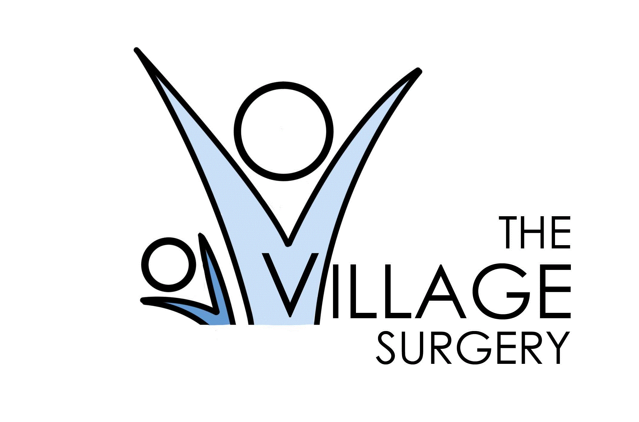 Patient Newsletter December 2025

MERRY CHRISTMAS AND A HAPPY NEW YEAR TO ALL OUR PATIENTS

This year we are running a community donation bank, we encourage our community to donate non-perishable foods as well as new items of clothing, including things such as scarfs or even blankets. Donations can be dropped off at reception, and any donations will be greatly appreciated.

NHS APP – Stay Connected!
Where to download it?
You can download the app via google play or the app store. For more information see the following QR code:
 We encourage all our patients to get the app as it helps both us and yourselves.
Why should you get it?
✔️ Book and manage appointments
✔️ Order repeat prescriptions
✔️ View your test results
✔️ Check your vaccination record
✔️ Access your medical record securely
✔️ Receive important messages from the practice

Social Prescriber
The surgery is now encouraging more engagement with the social prescriber, who empowers people to take control of their health and wellbeing, by connecting them with appropriate resources.
What is the purpose of the role?
Offer support for non-medical problems such as:
- Pain management
- Carers/ Carers Support
- Talking therapy/ Agoraphobia / Social isolation
- Bereavement support
- Weight loss

What they don't do:
- Counselling
- Form filling
- Home visits (all done over phone/text)

Did you know:
- 64% of users told us that the NHS App was the first app they had downloaded that was paired with their NHS number and medical record at their GP practice.
- 20% of patients who received an SMS promoting the NHS App clicked on the link to get more information.

👧🧒 0 – 5 immunisation campaign – vaccinating our next generation.
Keeping children healthy is one of the best ways we can protect our community. That’s why vaccination is so important.
Why get vaccinated?
- ✅ Protects your child – vaccines help prevent serious illness such as: Flu, MMR, Diphtheria, Tetanus, Polio & HPV
- ✅ Protects others – If enough people are vaccinated, it provides Herd immunity which reduces the spread of infections to family, friends, and the wider community
- ✅ Protects the future – helps keep schools, clubs, and activities running smoothly
Vaccines are safe, effective, and one of the best ways to give children a healthy start in life.
If your child is eligible for vaccination, please take up the invitation when it arrives. Together, we can keep our children and community safe.
👉 Your child’s health matters – please say yes to vaccination.

Practice Website
We encourage all our patients to regularly visit our Practice Website for the latest news and updates about our services, clinics, and health campaigns.
Don’t forget to check out our Patient Zone page, where you’ll find:

- Helpful links to trusted national health resources
- Information about local support services and community groups
- Guidance to help you manage your health and wellbeing
👉 Visit us online today to stay connected and informed.
https://www.villagesurgeryderby.org.uk/

Your Voice Matters – Help Us Improve Village Surgery
At Village Surgery, we believe the best way to improve our services is by listening to the people who use them – you, our patients.
Why your feedback is important:
- ✅ It helps us understand what we’re doing well
- ✅ It highlights areas where we can do better
- ✅ It shapes future services to meet the needs of our community
We want every patient to feel heard. Your experiences, suggestions, and ideas will directly influence how we provide care now and in the future.
How you can get involved:
- Complete Friend & Family feedback (through our website)
- Take part in patient surveys
- Share your views with our Patient Participation Group (PPG)

Follow us on Facebook!! @VillageSurgeryDerby
Please follow us for regular updates and Surgery news

DNA Data – August 2025

Over the month of August, we had 135 missed appointments, that means 135 patients could have been seen at Village Surgery!
This number is also rapidly increasing from month to month.

Closed Dates

Staff training

- Wednesday 17th September from 1.30pm
- Wednesday 15th October from 1.30pm
- Wednesday 19th November from 1.30pm

Christmas & New Year Bank Holidays

- Thursday 25th December
- Friday 26th December
- Thursday 1st January

During these times 111 or the walk-in centre are available for urgent medical attention. Or call 999 for life-threatening emergencies.

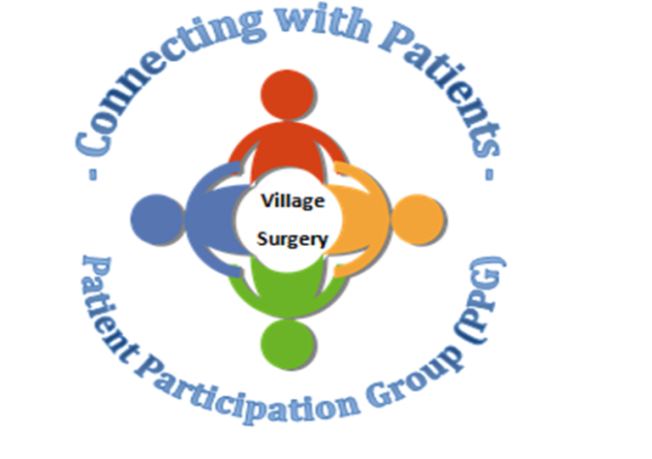

Relias training
There is still a lot of online training outstanding. Please complete as soon as possible.
https://villagesurgeryderby.training.relias.co.uk

If you are unsure of your log on details let Claire or Lauren know.
Autumn 2019

Autumn 2019
Upcoming Quest Sessions
• 20th November 2019—we are hoping to do a ‘scenario’ afternoon. As emergency situations are an ‘emergency’ we don’t get to practice before they happen. This will be an opportunity for staff to practice these emergency situations and also to highlight areas that need attention.
• 18th December 2019—Christmas fuddle. We will be having a fun Christmas afternoon, exchanging secret Santa gifts, eating food and playing games.

